**Unit 3 Movie Database Design with SSMS**

Corey Crooks

Purdue University Global

IT234 – Leon King

May 2, 2021

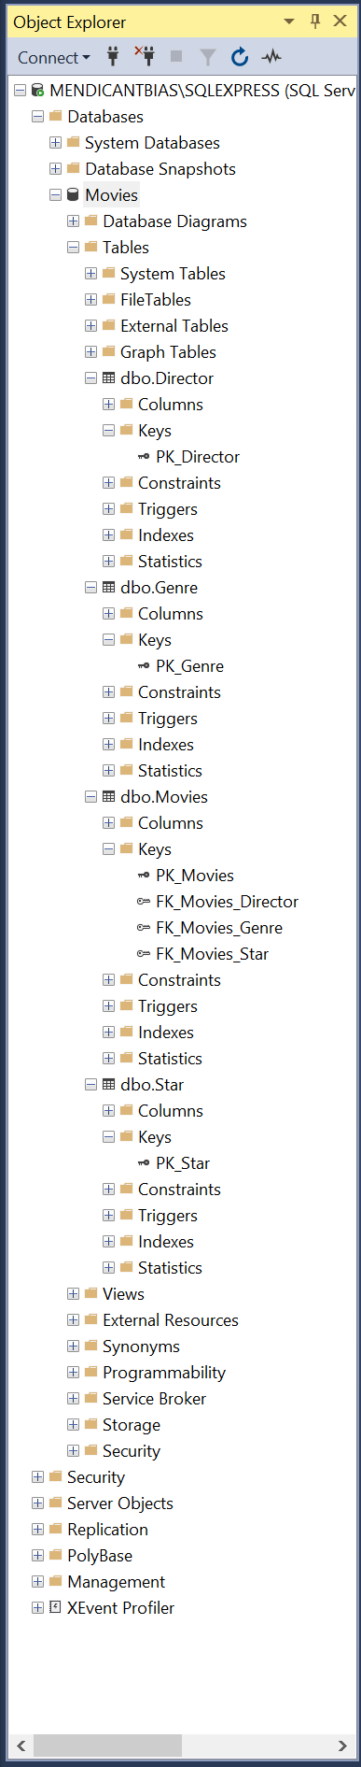

<-My finalized Object Explorer map showing 1. The constructed Movies database. 2. The dbo Table Entities required for the database. 3. The primary keys for each table. 4. The foreign keys for each table.

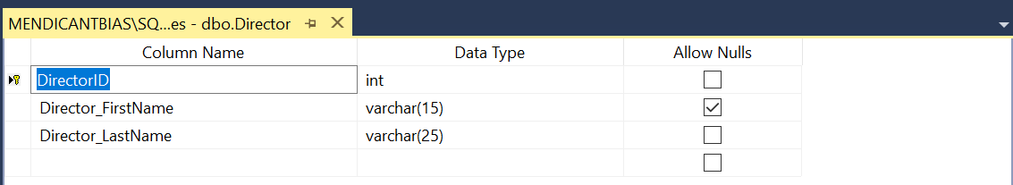

Above is a screenshot of the Director table entity. This includes the attributes DirectorID (an integer), Director_FirstName (an up to 15 letter string), and Director_LastName (an up to 25 letter string). The Primary key of this table is DirectorID. Only the first name is allowed to be left blank.

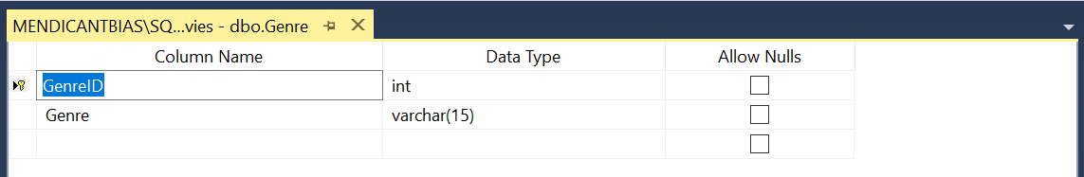

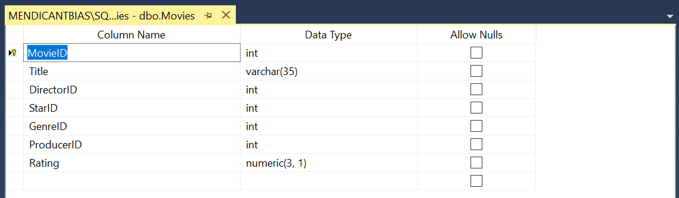

Above is a screenshot of the Genre table entity. This includes the attributes GenreID (an integer), and Genre (an up to 15 letter string). The Primary key of this table is GenreID. No value in this table is allowed to be left blank.

Above is a screenshot of the Movies table entity. This includes the attributes MovieID (an integer), Title (an up to 35 letter string), DirectorID (an integer), StarID (an integer), GenreID (an integer), ProducerID (an integer), and Rating (a decimal with up to three numbers to the left of the decimal and one number to the right). The Primary key of this table is MovieID. The Foreign keys of this table are DirectorID, StarID, GenreID, and ProducerID. No values in this table are allowed to be left blank.

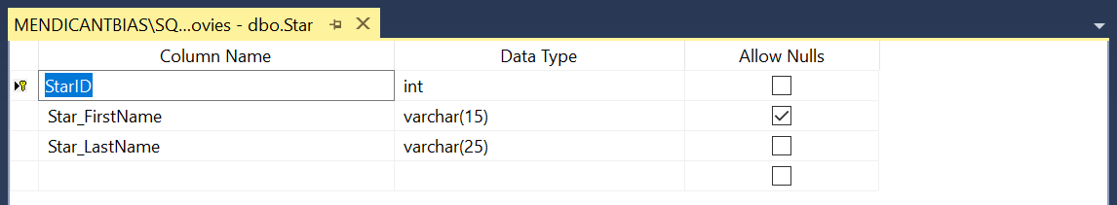

Above is a screenshot of the Star table entity. This includes the attributes StarID (an integer), Star_FirstName (an up to 15 letter string), and Star_LastName (and up to 25 letter string). StarID is the primary key of this table. Only Star_FirstName is allowed to be blank.